ICS-365 HW3

\* Due Date – See Class Schedule \*

\* Use your own words to answer the questions, do not cut and paste from another source, that is cheating \*

1. Parse Tree for D=C\*B

Given this BNF:

<assign> → <id> = <expr>

<id> → A | B | C | D

<expr> → <id> + <expr>

| <id> \* <expr>

| (<expr>)

| <id>

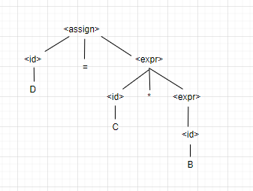

1. Parse Tree for A=(A+B) / (C+D) - same BNF as 1

Syntax error, there is no “/” or division in the given BNF

1. Parse Tree for A=A+D\*C+D - same BNF as 1

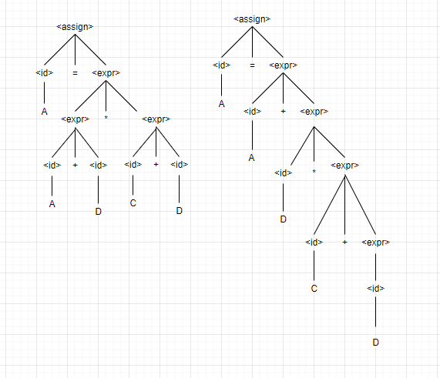

1. What is the difference between synthesized and inherited attributes?
   1. Inherited attributes depend on information from descendants in the parse tree.
   2. Synthesized attributes are not computed.
   3. Inherited attributes are useful only in object-oriented languages.
   4. Synthesized attributes depend on information from descendants in the parse tree.
2. Some features that cannot be captured and/or enforced by BNF, can be done using Attribute grammars.
   1. TRUE
   2. FALSE